**KPop Demon Hunters**

Carb Loading

**Part 1 Vocabulary Preview** *Before you watch the video, try to guess what the underlined expressions mean from context clues.*

1. Marathon runners often carb load one to three days before a race.
2. Sorry, no time to talk. I have a gajillion things to do before the concert tonight.
3. My friend just got the sickest Blackpink tattoo last week. I think I’m going to get one too.
4. I don’t have your money yet. But keep your shirt on. I’ll give it to you soon.
5. Is that my phone? Gimme that!
6. If you mess with my family, I will find you and make it hurt!

**Part 2 Background & Gist**



Mira Zoey Rumi Bobby

* Mira, Zoey, and Rumi are in a K-pop idol group called HUNTR/X.
* They are also demon hunters. They defend the world from demons.
* Bobby is the manager of HUNTR/X.
* They are flying to their next concert.

*As you are watching the video, think about:* **What problems do the girls complain about? How do they know that flight crew are demons?**

**Part 3 Comprehension** *After you watch the video, decide if each statement is true or false.*

1. **T / F** The girls need to eat because they skipped breakfast.
2. **T / F** The ramyeon is missing hot water.
3. **T / F** Mira likes the man’s tattoo.
4. **T / F** Bobby is upset because the group is late for the show.
5. **T / F** Rumi tells Bobby they will arrive in 10 minutes.
6. **T / F** The demons always seem to interrupt their concerts.
7. **T / F** Mira finishes eating her ramyeon before the fight.
8. **T / F** The demons plan to eat their fans.

**Part 4 Discussion** *Discuss these questions with your partner or group.*

1. What do you think is going to happen next? How are they going to get to the show?
2. What new things did you learn about the three main characters in this video?
3. Which Korean food and snacks can you recognize in the video? Which have you tried? Which do you want to try?
4. Do you ever carb load? Why?
5. If you need energy, what is your go-to food or snack?
6. Why do you think HUNTR/X cares so much about their fans?
7. In your opinion, what group or artist (K-pop or non-K-pop) seems to care the most about their fans? What is your evidence?

**Part 5 Language Review**  *Choose the word or expression from the video that best matches the highlighted expressions.*

1. Okay, it's time for our **[ warm-up, preparation ]** ramyeon!
2. A: Yo! I just got this tattoo!

B: **[ Awesome ]**.

1. **[ Give that to me ]**! Why are you so late?
2. **[ Relax, Calm down ]**, Bobby. We'll be there in three.
3. They will face my **[ anger, revenge ]**!
4. Please **[ sit down ]**.
5. You're smiling all weird, **[ giving water to ]** plants with coffee, and those guys? Come on.
6. When you **[ attack ]** our fans, we need to make it hurt.

**Part 6 Language Review**  *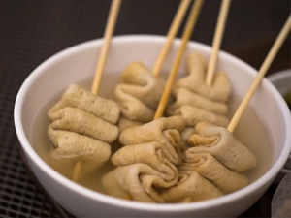Match these popular Korean snacks to the pictures below.*

Hotteok (호떡) Kimbap (김밥) Naengmyeon (냉면) Odeng (오뎅)

Ramyeon (라면) Shrimp crackers (새우깡) Soondae (순대) Tteokbokki (떡볶이)

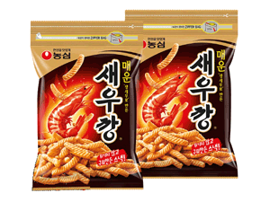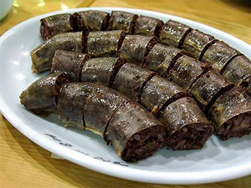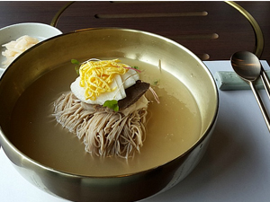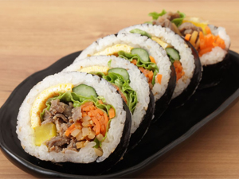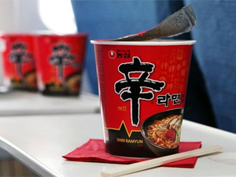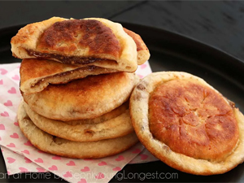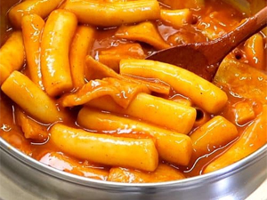

**

*Which of these snacks did you see in the video?*

**Part 6 Sentence Building**  *Write sentences about the video clip using the words given. You can change the word form or add words, but you cannot change the word order. Use a present time frame (tenses).*

E.g. HUNTR/X / on / way / big / show / yet

HUNTR/X is on its way to its biggest show yet. **(HUNTR/X is = one group)**

HUNTR/X are on their way to their biggest show yet. **(HUNTR/X are = three people)**

1. Rumi / joke / she / need / 10,000 / calorie / just / get / through / choreo
2. so / they / start / carb / load / by / stuff / self / with / mountain / Korea / snack
3. as / they / prepare / eat / pre-game / ramyeon / they / discover / there / no / hot / water
4. when / Rumi / ask / flight / attendant / water / she / begin / suspect / something / *up

\***something is up**: something wrong or suspicious is happening

1. instance / she / notice / flight / attendant / water / plant / coffee
2. then / Bobby / call / and / ask / why / they / late / show
3. some / fan / steal / Bobby / phone / and / tell / girl / how / much / they / love / HUNTR/X.
4. then / Rumi / sudden / reveal / crew / member / actual / demon
5. captain / demon / tell / HUNTR/X / they / plan / eat / fan
6. so / they / get / angry / and / prepare / fight / demon

**Script** *.*

**Rumi:**  Okay, this is our biggest show yet.

**Zoey:** The most songs.

**Mira:** The most moves.

**Rumi:** Which means the most carb loading.

**HUNTR/X:** For the fans!

**Rumi:** I need 10,000 calories to get through the choreo.

**Mira:** A thousand percent. A gajillion percent.

**Rumi:** Man, that's not even a real number.

**Mira:** It is for our fans.

**Rumi:** Ah! Our fans deserve the best.

**Rumi:** Okay, time for our pre-game ramyeon!

**HUNTR/X:** Happy fans, happy Honmoon!

**Zoey:** Wait, there's no water in these.

**Rumi:** Excuse me, miss?

**Attendant:** Yes, Miss Hunter-ix?

**Rumi:** We asked for hot water...

**Attendant:** Right away. You're welcome. Arrivederci. Goodbye.

**Rumi:** Uh, okay.

**HUNTR/X:** Hi, Bobby!

**Bobby:** Yeah, hi! What are you doing?

**Rumi:** About to eat our pre-show ramyeon.

**Bobby:** Pre-show? What about the show-show? Hey, that's my phone!

**Fangirls:** We love you!

**HUNTR/X:** Oh, we love you too!

**Rumi and Mira:** That's so sweet.

**Fanboy:** Yo! I just got this!

**Mira:** Sick.

**Bobby:** Gimme that! Why are you so late?

**Zoey:** Late?

**Bobby:** Fifty thousand fans are waiting for you. They made cute signs and everything. How can you be late? I wish you were here.

**Rumi:** Keep your shirt on, Bobby. We'll be there in three.

**Mira:** I didn't even get to finish my ramyeon!

**Rumi:** Why do they always interrupt our snacking?

**Zoey:** They will face my wrath!

**Rumi:** Um, excuse me?

**Attendant:** Please take your seat.

**Rumi:** Yeah. We don't have time. You're a demon, right?

**Attendant:** What do you mean?

**Rumi:** You're smiling all weird, watering plants with coffee, and those guys? Come on.

**Attendant:** Oh, we were just...

**Rumi:** Oh, look! Patterns.

**Attendant:** Oh, these? These are just...

**Rumi:** The rest of you can come out. We're in a hurry!

**Mira:** Oh, you got the patterns. Now you've got to die.

**Demon:** The only ones dying tonight are your

**Mira:** *(burp)*

**Demon:**  I said, the only ones dying tonight are your...

**Rumi:** *(stomach grumbling)* I'm sorry, what?

**Demon:** Your fans! We're going to eat your fans!

**HUNTR/X:** Whoa!

**Mira:** No.

**Zoey:** No, thank you!

**Mira:** No, no, no.

**Rumi:** Not our fans.

**Zoey:** When you mess with our fans...

**Mira:** ...we need to make it hurt.

**Answers .**

**Part 3**

1. **TRUE** The demons in this world take strength from human souls.
2. **FALSE** The girls need to eat because they skipped breakfast.
3. **TRUE** The ramyeon is missing hot water.
4. **TRUE** Mira likes the man’s tattoo.
5. **TRUE** Bobby is upset because the group is late for the show.
6. **FALSE** Rumi tells Bobby they will arrive in 10 minutes.
7. **FALSE** The demons always seem to interrupt their concerts.
8. **FALSE** Mira finishes eating her ramyeon before the fight.
9. **TRUE** The demons plan to eat their fans.

**Part 5**

1. Okay, it's time for our **[ pre-game ]** ramyeon!
2. A: Yo! I just got this tattoo!

B: **[ Sick ]**!

1. **[ Gimme that ]**! Why are you so late?
2. **[ Keep your shirt on ]**, Bobby. We'll be there in three.
3. They will face my **[ wrath ]**!
4. Please **[ take your seat ]**.
5. You're smiling all weird, **[ watering ]** plants with coffee, and those guys? Come on.
6. When you **[ mess with ]** our fans, we need to make it hurt.

**Part 6**

1. Rumi jokes (that) she needs 10,000 calories just to get through the choreo.
2. So, they start carb loading by stuffing themselves with a mountain of Korean snacks.
3. As they [are preparing/prepare] to eat their pre-game ramyeon, they discover (that) there is no hot water.
4. When Rumi asks a flight attendant for (some) water, she begins to suspect (that) something is up.
5. For instance, she notices (that) the flight attendant is watering a plant with coffee.
6. Then Bobby calls (them) and asks (them) why they are late for [their/the] show.
7. Some fans steal Bobby's phone and tell the girls how much they love HUNTR/X.
8. Then Rumi suddenly reveals (that) the crew members are actually demons.
9. The captain demon tells HUNTR/X (that) they plan to eat their fans.

The captain of the demons tells HUNTR/X (that) they plan to eat their fans.

1. So, they get angry and prepare to fight the demons.